## **nintendo_soc_profile_fireemblem_grey.png**

## **Y’all know what time it is! It's Nintendo Society News Time!**

If you received this email then massive thank you for becoming a member of the society (and you can ignore the part of joining the society from the SocsFair mailing list)! :D

Remember guys, if you want to be receiving these emails each week then make sure to go to the Warwick SU website and you can pay for membership there! I’ll stop sending these emails to those who haven’t joined from Week 5, so join! :D

We were amazed by the turnout last week so thank you all for that achievement! And we have more fun things planned for the coming weeks so keep an eye out!

Similar to last week, if you own any consoles / controllers yourself which you would like to bring along then we would appreciate this a lot! Absolutely no worries if you can’t though as we will provide as much equipment as we own!

And with that, here are this week's announcements:

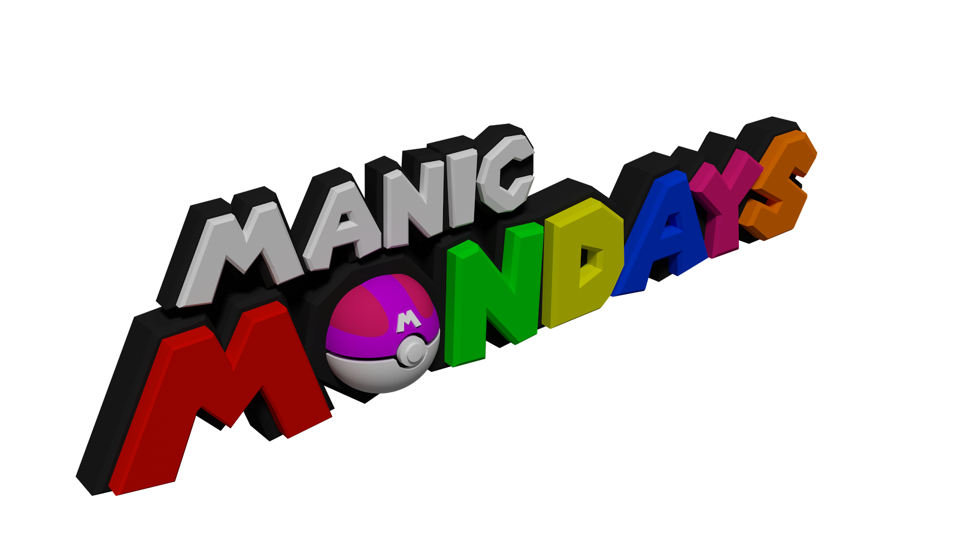

### **Monday 16/10, R1.13 & R1.15 (Ramphal Building), 5pm setup, 6-10pm**

Manic Mondays are all about enjoying Nintendo games! We will have 3DS’s, Wii U’s and Switch’s around for all of you to have a play on some of Nintendo’s finest games!



### **Wednesday 18/10, Pub (Dirty Duck / Varsity), 2-4pm**

Come have some afternoon lunch before Smash (or just for a general relax with us) and get to know everyone a little better in our mini pub social! A poll will be made on Facebook to decide where we should go, so vote!

### **Wednesday 18/10, R0.03/4 (Ramphal Building), 4-10pm**

This is our weekly Smash Bros. event! Wednesdays are dedicated gaming sessions for Super Smash Bros. for Wii U and Melee! Open to all skill levels from complete casual to more competitive level, and we will have multiple setups of each!

If you don’t know where the Ramphal Building is on campus then use the following link! We will have a banner outside the room to indicate where we are! <https://campus.warwick.ac.uk/?cmsid=18&project_id=1>

---------------------------------------------------------------------------------------

And that’s all the time we’ve got! Until next time…

Don’t get cooked… Stay off the hook! :D

Timothy Sit

Nintendo Society President

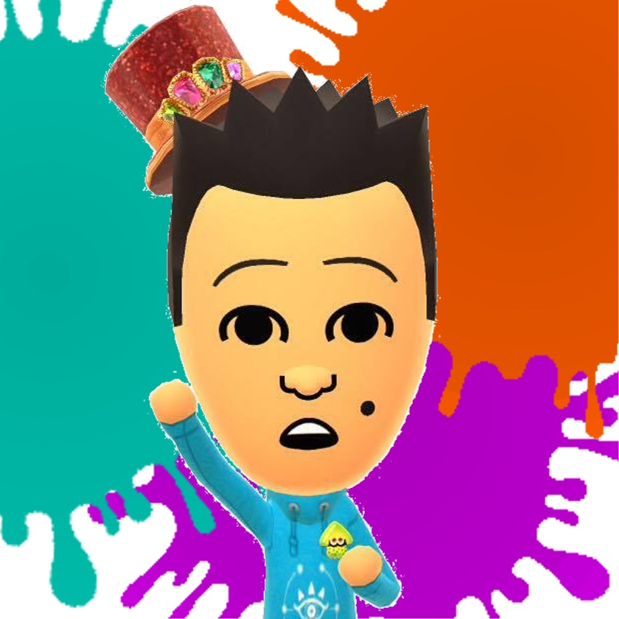

---------------------------------------------------------------------------------------

### **Find us on Social Media:**

Join our Facebook group:<https://www.facebook.com/groups/warwicknintendo/>

Follow our Twitter:<https://twitter.com/warwicknintendo>

Join our Discord Chat:<https://discordapp.com/invite/Rf6QyfG>

Subscribe to our YouTube:<https://www.youtube.com/channel/UCzO_bZNfQDCAQa_zkEUgGVg>